W311R (W311R+)-How to configure DDNS function (R)?
Product line: wireless Question category: function configuration

Q：Why we need to configure the DDNS?
A：If your Internet connection Type is PPPoE or Dynamic IP etc, the WAN IP Address will change every time after you set the router. In order to access the hosting website, FTP server in the LAN of the router at anytime anywhere, we need bind a domain name with dynamic WAN IP address, then you can access the servers with domain name. You can achieve this through set DDNS.

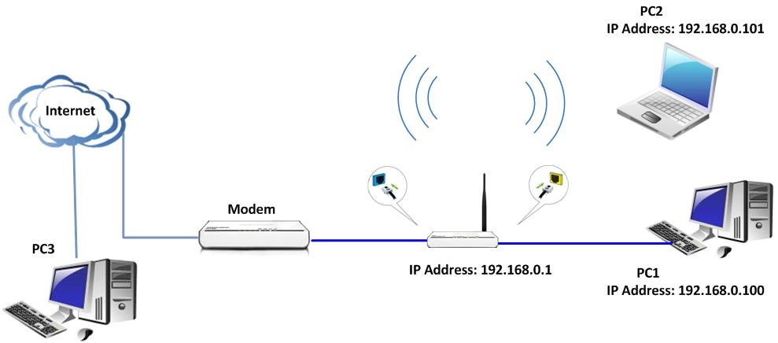

Steps are as following:
- Login the management page of the router.(the login IP is default to be 192.168.0.1 ,username and password are both admin).
- In the management page of the router, please select System Tools->DDNS on the left side.

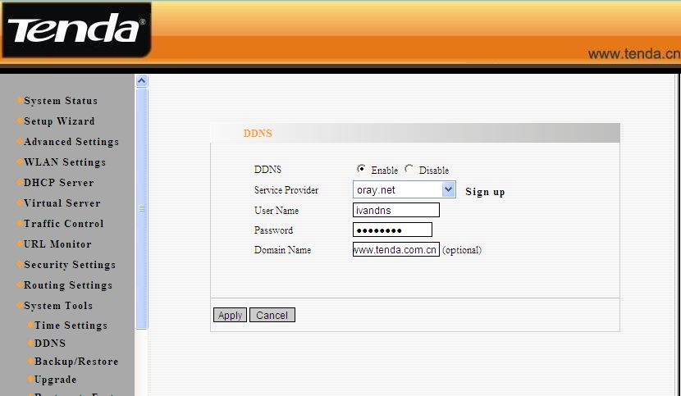

(1) Tick the Enable option to enable the DDNS service.
(2) Select one Service Provider from the drop-down menu and press Sign up for registration. After the registration, you will get the User Name and Password and Domain Name information.
(3) Enter the user name the same as the registration name.
(4) Enter the password you set when do the ddns registration.
(5) Enter the domain name.
3. Click Apply to save the settings.

After the settings, you can access hosting website, FTP server with domain name instead of WAN IP address.
For example: ftp://www.tenda.com.cn not ftp://12.142.13.165

